# **Abstract Code - Search Resource**

While no buttons are pushed, do nothing;

//populate dropdowns

SELECT ID_description FROM ESF;

SELECT Inc_ID, Description FROM INCIDENT;

If data validation is successful for all Keyword($Keyword), ESF($ID_description), Location_distance($Distance) and Incident($Inc_ID, $Description):

If ***Search*** button is pushed, then do the following:

Display Search Result table according to search conditions;

SELECT R.Res_ID, R.Res_name, R.Username, R.Price, R.Costunit, R.Status, R.Available_date, Distance

FROM RESOURCES AS R INNER JOIN RES_CAP ON RESOURCES. Res_ID= RES_CAP. Res_ID

WHERE (Res_name LIKE $Keyword OR Model LIKE $Keyword OR Res_capability LIKE $Keyword) AND (ID_desc LIKE $ID_description) AND (Distance<=$Distance)

ORDER BY Distance ASC;

/* Distance is calculated by application through *haversine* formula */

else if ***Cancel*** button is pushed: go to **ERMS main menu** of user;

else if data input fields are invalid, go to **Search Resource** form, with error message;

**Search Result**

Find the Incident according to search conditions;

Display the name($Description) and ID($Inc_ID) of incident;

Find the resources according to search conditions;

Display the resources($Res_ID) and their attributes, sorted by distance, then availability($Status) and then name($Res_name);

While no buttons are pushed, do nothing;

While a button is pushed, then do the following:

If ***Deploy*** button is pushed, then do the following: Update resource; Input expected return time;

//update status

for each $Status

UPDATE RESOURCES

SET Status=’NOT AVAILABLE’

WHERE Res_name=$Res_name AND Res_ID=$ Res_ID

end for

else if ***Repair*** button is pushed: Update resource; Display **Repair** form;

input repair start date($Rep_start) and available date ($Available_date)

for each $Status, $Rep_start, $Available_date

UPDATE RESOURCES

SET Status=’IN REPAIR’, Rep_start=$Rep_start, Available_date=$ Available_date

WHERE Res_name=$Res_name AND Res_ID=$Res_ID

end for

else if ***Request*** button is pushed: Update resource; update request; Display **Rquest** form;

input request start date($Start_date) and return date ($Return_by)

for each $Start_date, $Return_by

UPDATE REQUEST

SET Start_date=$Start_date, Return_by=$Return_by

WHERE Res_ID=$Res_ID

end for

else if ***Close*** button is pushed: Go to **ERMS main menu** of user;

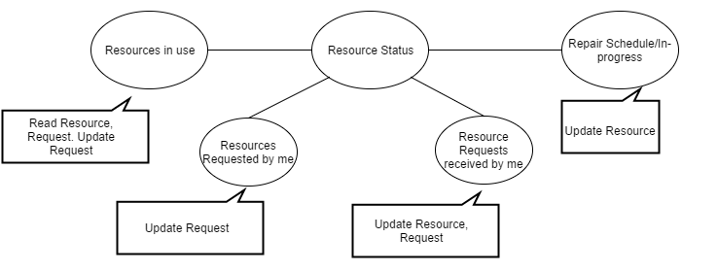

# **Abstract Code w/ SQL- Resource Status**

# **Resources in use**

//application provides $Username of current user

//showing resources in use

SELECT R.Res_ID, R.Res_name, I.Description, R.Username, RE.Start_date, RE.Return_by

FROM RESOURCES AS R INNER JOIN REQUEST AS RE ON R.Res_ID = RE.Res_ID INNER JOIN

INCIDENT AS I ON I.Inc_ID = RE.Inc_ID

Where I.Username = $Username AND R.Status = “in use”

SORT BY R.Res_ID

If ***Return*** button is pressed, then do the following: Update resource;

for each $Status

UPDATE RESOURCES AS R

SET R.Status = “available”

WHERE R.Res_ID = $Res_ID

# **Resources requested by me**

//application provides $Username of current user

//showing resources requested by me

SELECT R.Res_ID, R.Res_name, I.Description, R.Username, RE.Return_by

FROM RESOURCES AS R INNER JOIN REQUEST AS RE ON R.Res_ID = RE.Res_ID INNER JOIN

INCIDENT AS I ON I.Inc_ID = RE.Inc_ID

WHERE I.Username = $Username AND R.Status != “in use”

SORT BY R.Res_ID

If ***Cancel*** button is pressed, then do the following: cancel request;

for each $Status

DELETE FROM REQUEST

WHERE REQUEST.Res_ID = $Res_ID

# **Resources Requests received by me**

//application provides $Username of current user

//showing resources received by me

SELECT R.Res_ID, R.Res_name, I.Description, R.Username, RE.Return_by

FROM RESOURCES AS R INNER JOIN REQUEST AS RE ON R.Res_ID = RE.Res_ID INNER JOIN

INCIDENT AS I ON I.Inc_ID = RE.Inc_ID

WHERE R.Username = $Username

SORT BY RE.Return_by

If ***Deploy*** button is pressed, then do the following: Update resource;

for each $Status

UPDATE RESOURCES AS R

SET R.Status = “in use”

WHERE R.Res_ID = $Res_ID

If ***Reject*** button is pressed, then do the following:Cancel request;

for each $Res_ID

DELETE FROM REQUEST

WHERE REQUEST.Res_ID = $Res_ID

# **Repairs Schedule/ In-Progress**

//application provides $Username of current user

//showing repairs schedule/In-process

SELECT R.Res_ID, R.Res_name, R.Rep_start, R.Rep_ready

FROM RESOURCES AS R

WHERE R.Username = $Username AND R.Status = “in repair”

If ***Cancel*** button is pressed, then do the following: Cancel request;

for each $Status

UPDATE RESOURCES AS R

SET R.Status = “available”

WHERE R.Res_ID = $Res_ID